**Do zoos help or harm animals?**

What do you think? Do you agree or disagree? Perhaps you can think of ideas for both sides of this topic.

**Write to convince a reader of your opinion:**

* Start with an introduction.
* Write your opinion on this topic.
* Give reasons for your opinion.
* Explain your reasons for your opinion in your body paragraphs.
* Finish with a conclusion. Sum up your writing to convince a   
  reader of your opinion.

**Remember to:**

* 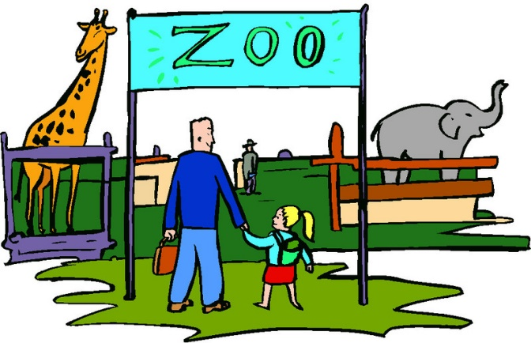Plan your argument.
* Choose your words carefully to convince a reader.
* Write in full sentences.
* Pay attention to spelling and punctuation.
* Use paragraphs to organise your ideas.
* Check and edit your writing.